**Vampire**

*Medium undead (shapechanger), lawful evil*

* **Armor Class**16 (Natural Armor)
* **Hit Points**144 (17d8+68)
* **Speed**30 ft.

**STR DEX CON INT WIS CHA**

18 (+4) 18 (+4) 18 (+4) 17 (+3) 15 (+2) 18 (+4)

* **Saving Throws**Dex +9, Wis +7, Cha +9
* **Skills**Perception +7, Stealth +9
* **Damage Resistance**Necrotic; Bludgeoning, Piercing, and Slashing From Nonmagical Attacks
* **Senses**Darkvision 120 Ft., passive Perception 17
* **Languages**The Languages It Knew In Life
* **Challenge**13 (10,000 XP)
* ***Shapechanger***. If the vampire isn't in sun light or running water, it can use its action to polymorph into a Tiny bat or a Medium cloud of mist, or back into its true form. While in bat form, the vampire can't speak, its walking speed is 5 feet, and it has a flying speed of 30 feet. Its statistics, other than its size and speed, are unchanged. Anything it is wearing transforms with it, but nothing it is carrying does. It reverts to its true form if it dies. While in mist form, the vampire can't take any actions, speak, or manipulate objects. It is weightless, has a flying speed of 20 feet, can hover, and can enter a hostile creature's space and stop there. In addition, if air can pass through a space, the mist can do so without squeezing, and it can't pass through water. It has advantage on Strength, Dexterity, and Constitution saving throws, and it is immune to all nonmagical damage, except the damage it takes from sunlight.
* ***Legendary Resistance (3/Day)***. If the vampire fails a saving throw, it can choose to succeed instead.
* ***Misty Escape***. When it drops to 0 hit points outside its resting place, the vampire transforms into a cloud of mist (as in the Shapechanger trait) instead of falling unconscious, provided that it isn't in sunlight or running water. If it can't transform, it is destroyed. While it has 0 hit points in mist form, it can't revert to its vampire form, and it must reach its resting place within 2 hours or be destroyed. Once in its resting place, it reverts to its vampire form. It is then paralyzed until it regains at least 1 hit point. After spending 1 hour in its resting place with 0 hit points, it regains 1 hit point.
* ***Regeneration***. The vampire regains 20 hit points at the start of its turn if it has at least 1 hit point and isn't in sunlight or running water. If the vampire takes radiant damage or damage from holy water, this trait doesn't function at the start of the vampire's next turn.
* ***Spider Climb***. The vampire can climb difficult surfaces, including upside down on ceilings, without needing to make an ability check.
* ***Vampire Weaknesses***. The vampire has the following flaws: Forbiddance. The vampire can't enter a residence without an invitation from one of the occupants. Harmed by Running Water. The vampire takes 20 acid damage if it ends its turn in running water. Stake to the Heart. If a piercing weapon made of wood is driven into the vampire's heart while the vampire is incapacitated in its resting place, the vampire is paralyzed until the stake is removed. Sunlight Hypersensitivity. The vampire takes 20 radiant damage when it starts its turn in sunlight. While in sunlight, it has disadvantage on attack rolls and ability checks.

Actions

* ***Multiattack (Vampire Form Only).*** The vampire makes two attacks, only one of which can be a bite attack.
* ***Unarmed Strike (Vampire Form Only).*** *Melee Weapon Attack:* +9 to hit, reach 5 ft., one creature. *Hit:*(1d8 + 4) bludgeoning damage. Instead of dealing damage, the vampire can grapple the target (escape DC 18)
* ***Bite (Bat or Vampire Form Only).*** *Melee Weapon Attack:* +9 to hit, reach 5 ft., one willing creature, or a creature that is grappled by the vampire, incapacitated, or restrained. *Hit:*(1d6 + 4) piercing damage plus (3d6) necrotic damage. The target's hit point maximum is reduced by an amount equal to the necrotic damage taken, and the vampire regains hit points equal to that amount. The reduction lasts until the target finishes a long rest. The target dies if this effect reduces its hit point maximum to 0. A humanoid slain in this way and then buried in the ground rises the following night as a vampire spawn under the vampire's control
* ***Charm.*** The vampire targets one humanoid it can see within 30 ft. of it. If the target can see the vampire, the target must succeed on a DC 17 Wisdom saving throw against this magic or be charmed by the vampire. The charmed target regards the vampire as a trusted friend to be heeded and protected. Although the target isn't under the vampire's control, it takes the vampire's requests or actions in the most favorable way it can, and it is a willing target for the vampire's bit attack. Each time the vampire or the vampire's companions do anything harmful to the target, it can repeat the saving throw, ending the effect on itself on a success. Otherwise, the effect lasts 24 hours or until the vampire is destroyed, is on a different plane of existence than the target, or takes a bonus action to end the effect.
* ***Children of the Night (1/Day).*** The vampire magically calls 2d4 swarms of bats or rats, provided that the sun isn't up. While outdoors, the vampire can call 3d6 wolves instead. The called creatures arrive in 1d4 rounds, acting as allies of the vampire and obeying its spoken commands. The beasts remain for 1 hour, until the vampire dies, or until the vampire dismisses them as a bonus action.

Legendary Actions

Vampire can take 3 legendary actions, choosing from the options below. Only one legendary action option can be used at a time and only at the end of another creature’s turn. Vampire regains spent legendary actions at the start of their turn.

* **Move.** The vampire moves up to its speed without provoking opportunity attacks.
* **Unarmed Strike.** The vampire makes one unarmed strike.
* **Bite (Costs 2 Actions).** The vampire makes one bite attack.

Describe room, couple candles, rug, several beds.

If they try to sleep anywhere else, they wake up every few minutes with the feeling they are being watched.

You awake to a very unpleasant noise, like metal sliding across stone. You are well rested, despite the abrupt wake up. The room is still dark/dim, but you can see a faint light leaking through in a square on the wall opposite to the door.

**What do you do?**

The wall moves out of your way…you think. Maybe you’re a little hazy from sleep.

A light fog slithers across the floor as you gaze into a hallway. The walls are dark, like obsidian, with nearly matching floors. The hallway itself is unlit, but you can identify a room at the end of the hall by the dimly glowing candle light.

As you enter the room, 3 of you are shocked as memories come rushing over you. The floor, the lighting, seem all too familiar.

**But from where?**

It is the final room you entered in the moving mansion. Haunting music floods the air as a shadowy figure emerges from the back of the room. A beautiful man (describe celestine) steps from the shadows, his white fangs protruding from his ruby lips.

“Welcome back” he says, his words sharp like razors.

*banter*

talk about the scepter they found that has the vampire on it. (once magic is unlocked they could control Celestine, but not in the dream anyway).

Talk about how they haven’t taken the necromancer down.

Talk about how the necromancer is going to give him the ability to walk in the sun permanently with the power of the scepter and immunity to running water.

Talk about how he will benefit from ‘the new world’ when humans will seek out his protection from the undead in exchange for their blood.

*/banter*

“I was concerned your crusade would become problematic, but it’s apparent that you neither have the desire nor organization to cause any real problems from the necromancer. Besides, you have already found the scepter for me. Your usefulness is growing thin. I will agree to let one of you live if you hand over the scepter immediately. Otherwise, I will take it from your corpse.”

**Battle**

**How it works**: SHHHHH! as they die, pass them a note saying they awake in the bedroom, with everyone in their bed. The passageway is still open. As you proceed down the hall, made of wood and stone, not obsidian, you see a hideous purple woman in the middle of the room. She seems to be concentrating on a spell.

(but she does not attack until everyone is awake. If they kill her while she’s still concentrating, she will not attack at all). If she kills everyone first, then she will heal and you’ll have to kill a hag. If you kill her first, everyone wakes up.

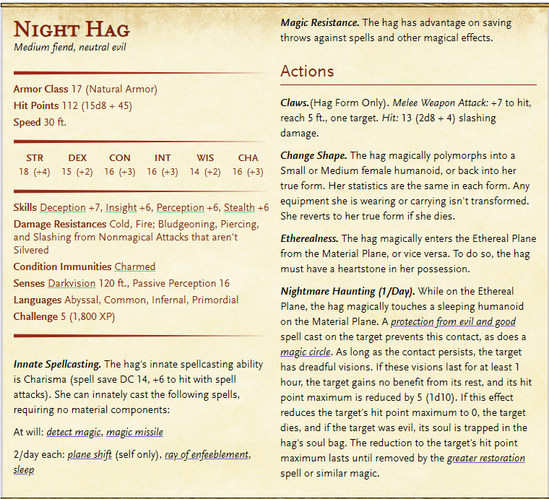

Each time you hit her, you notice the amulet glowing a little brighter. Magical necklace that heals 1d6 every turn.